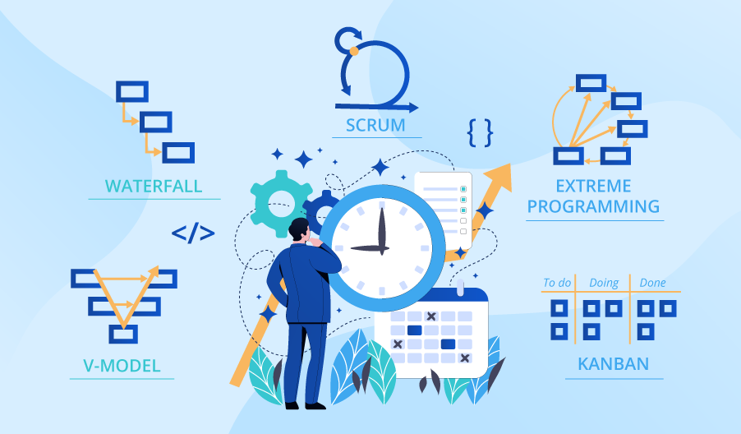

**SE423**

**Software Project Management**

**Assignment**

**Assignment 3.**

1. How do Waterfall, Agile, and DevOps approaches differ in their stakeholder management strategies?
2. What are some common challenges in stakeholder management, and how can project managers effectively address them?
3. How can effective stakeholder management contribute to project success, and what are some examples of this in practice?

Submit your answers to LMS as PDF file.